***An Introduction and Guide to Eduto-T***

Eduto is an integrated school administration and learning management system. Our aim is to maximize the convenience and save time for students and staff. The application for students has three main features, attendance taking, homework management, and lesson information. We intend to run a pilot of Eduto for teachers to test the reliability of the attendance taking function and gain some preliminary usage.

Bluetooth beacons will placed in various locations (e.g. HOD room). Whenever the user enters or leaves the room, their phone detects a signal and marks their attendance automatically. Compared with the previous method of signing in on a sheet of paper, the application provides more convenience as users do not even need to take their phone out of their pockets to mark their attendance. Digital records of attendance are stored for easy retrieval, saving on administrative work.

If the pilot is successful, we intend to expand the app’s coverage to students and all teachers. Using the online portal, teachers are able to immediately see which students are absent at the start of the lesson, and email notifications can be sent to teachers or parents. Furthermore, late coming of students over time can be monitored. More features will be added to streamline administration, such as announcements and daily quotes. It is our hope that this will eventually become a sustainable system that will provide value to the school.

Usage:

**Install links**: [Android](https://play.google.com/store/apps/details?id=com.dhs.edutoforteachers&hl=en) [IOS](https://itunes.apple.com/sg/app/eduto-for-teachers/id1143765157?mt=8)

Upon installing the application, accept the prompts to access location and contacts, then log in with your **DHS gmail account**. Please note that both bluetooth and an internet connection is required for attendance to be marked.

Below is the home screen of the app. Attendance is marked automatically upon entering the HOD room, however should a notification not appear, the manual attendance marking button can be used.

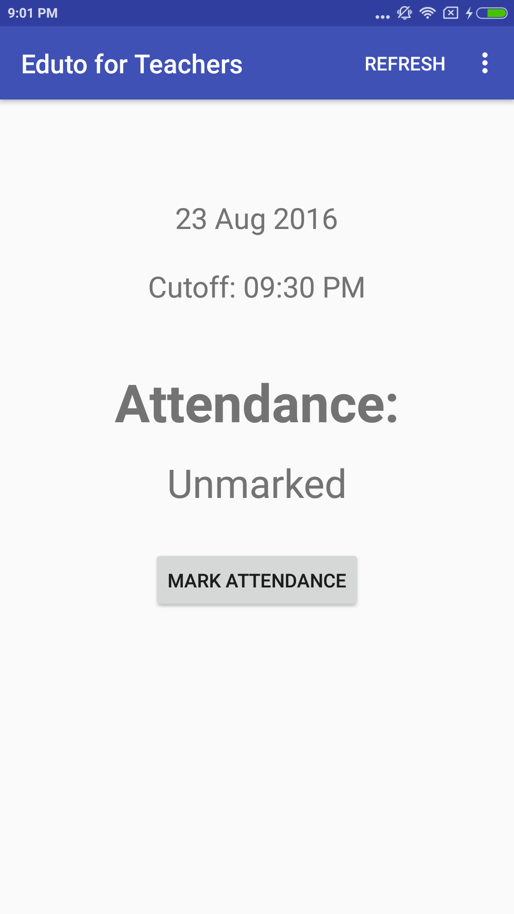

Upon successful recording of attendance, the following screen will be seen.

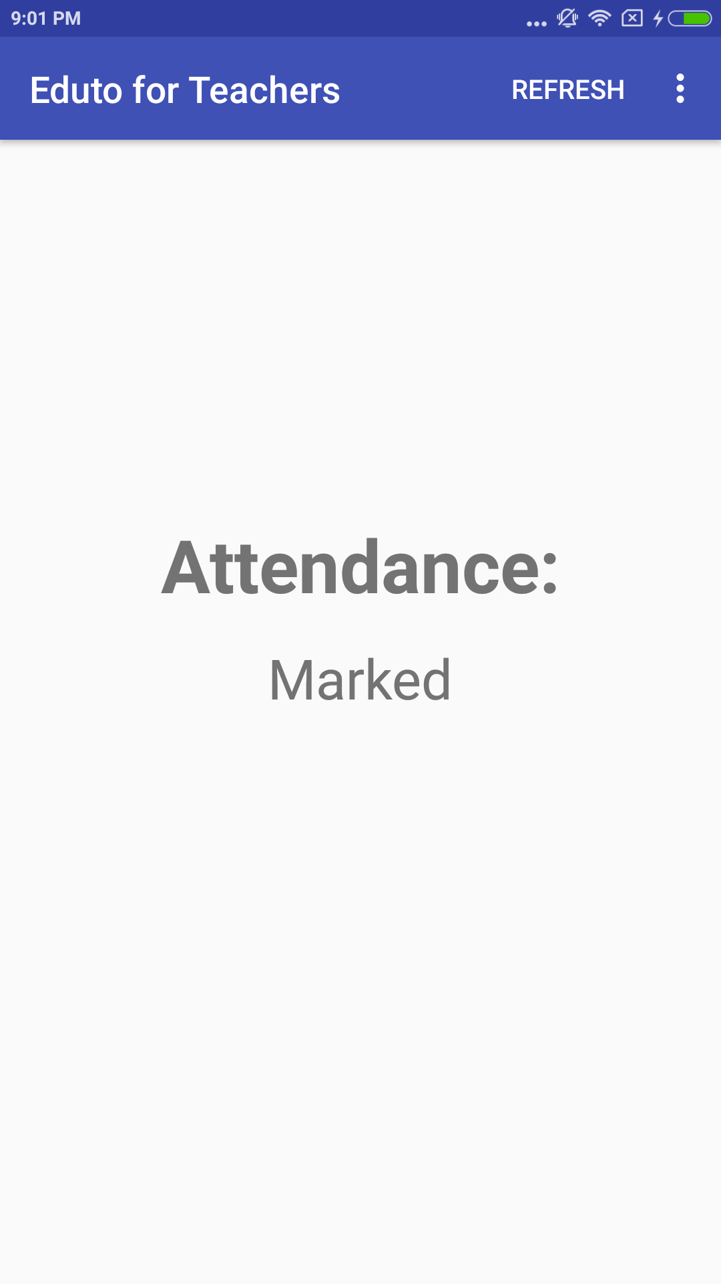

Admin Web Portal allows admin staff to check the attendance in real time.

